Thank you for downloading!
We're so glad you chose to download our fun little labels. We hope you enjoy them.
As noted on the labels, these can be printed onto Avery Printable Blank Oval Labels 2” x 3 1/3” (22820).
There are two designs of labels here. Both designs come with one blank template and one template with a text box set ready to be personalized.
These labels were designed with Microsoft Word. They will work with Googe Docs; however, the setting may be different. Please verify margins and settings if you are using Google Docs.
Tips for using
- After downloading, Save the master file to your computer.
- Now Safe As add TEST to the name (this protects the master file).
  - Now, delete extra pages, leaving only the page(s) you want.
  - Click ALT + Enter to create a new page
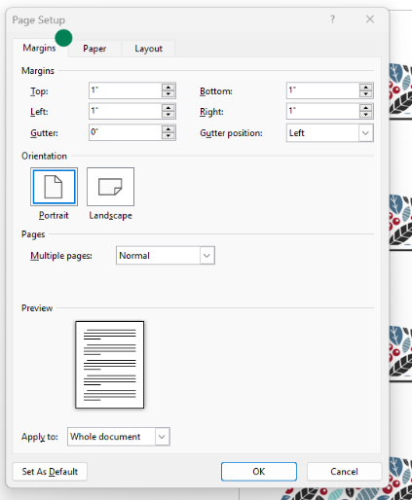
    - Click CRTL + D to duplicate the labels and drag to new page
Quick Tips for Printing:
Every printer can be set up differently; here are
the printer settings to help ensure your labels
print correctly.
Printer Settings:
- Paper Size: 8.5” x11”
- Orientation: Portrait
- Margins: 1” Top, Right, Left, and Bottom
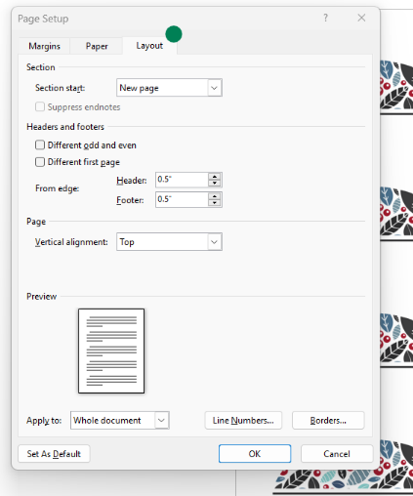
- Gutter: 0”
- Gutter Position: Left

Thanks again for downloading!
Tinkerington.com

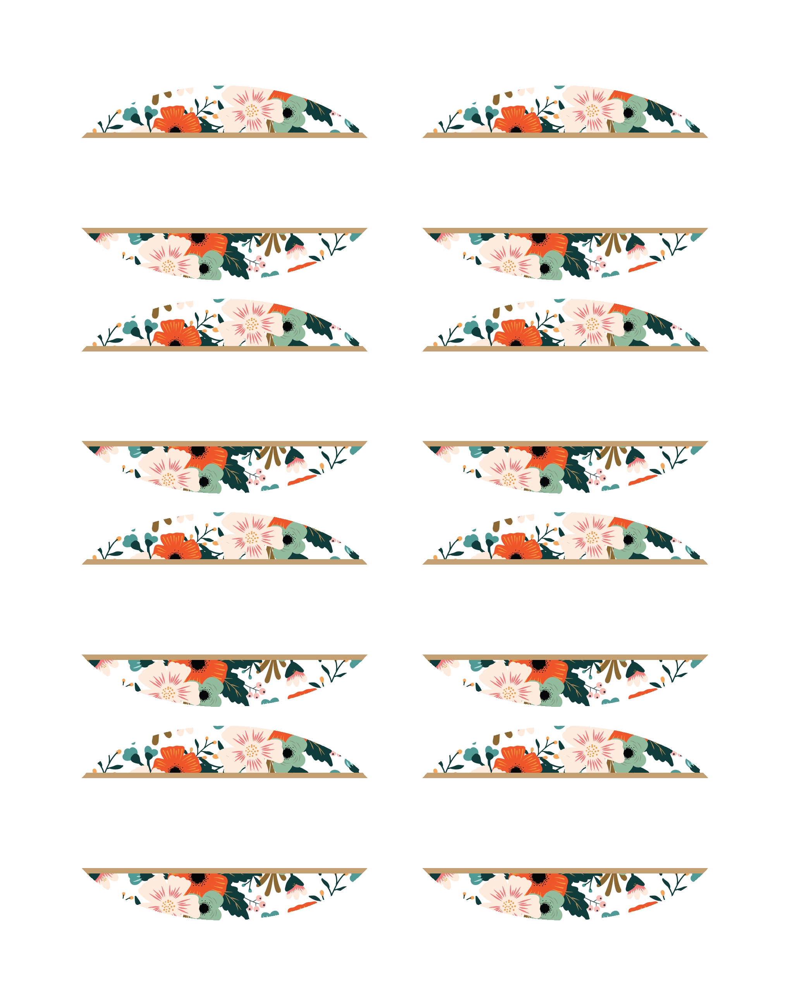
Fill in your text here
Fill in your text here
Fill in your text here
Fill in your text here
Fill in your text here
Fill in your text here
Fill in your text here
Fill in your text here
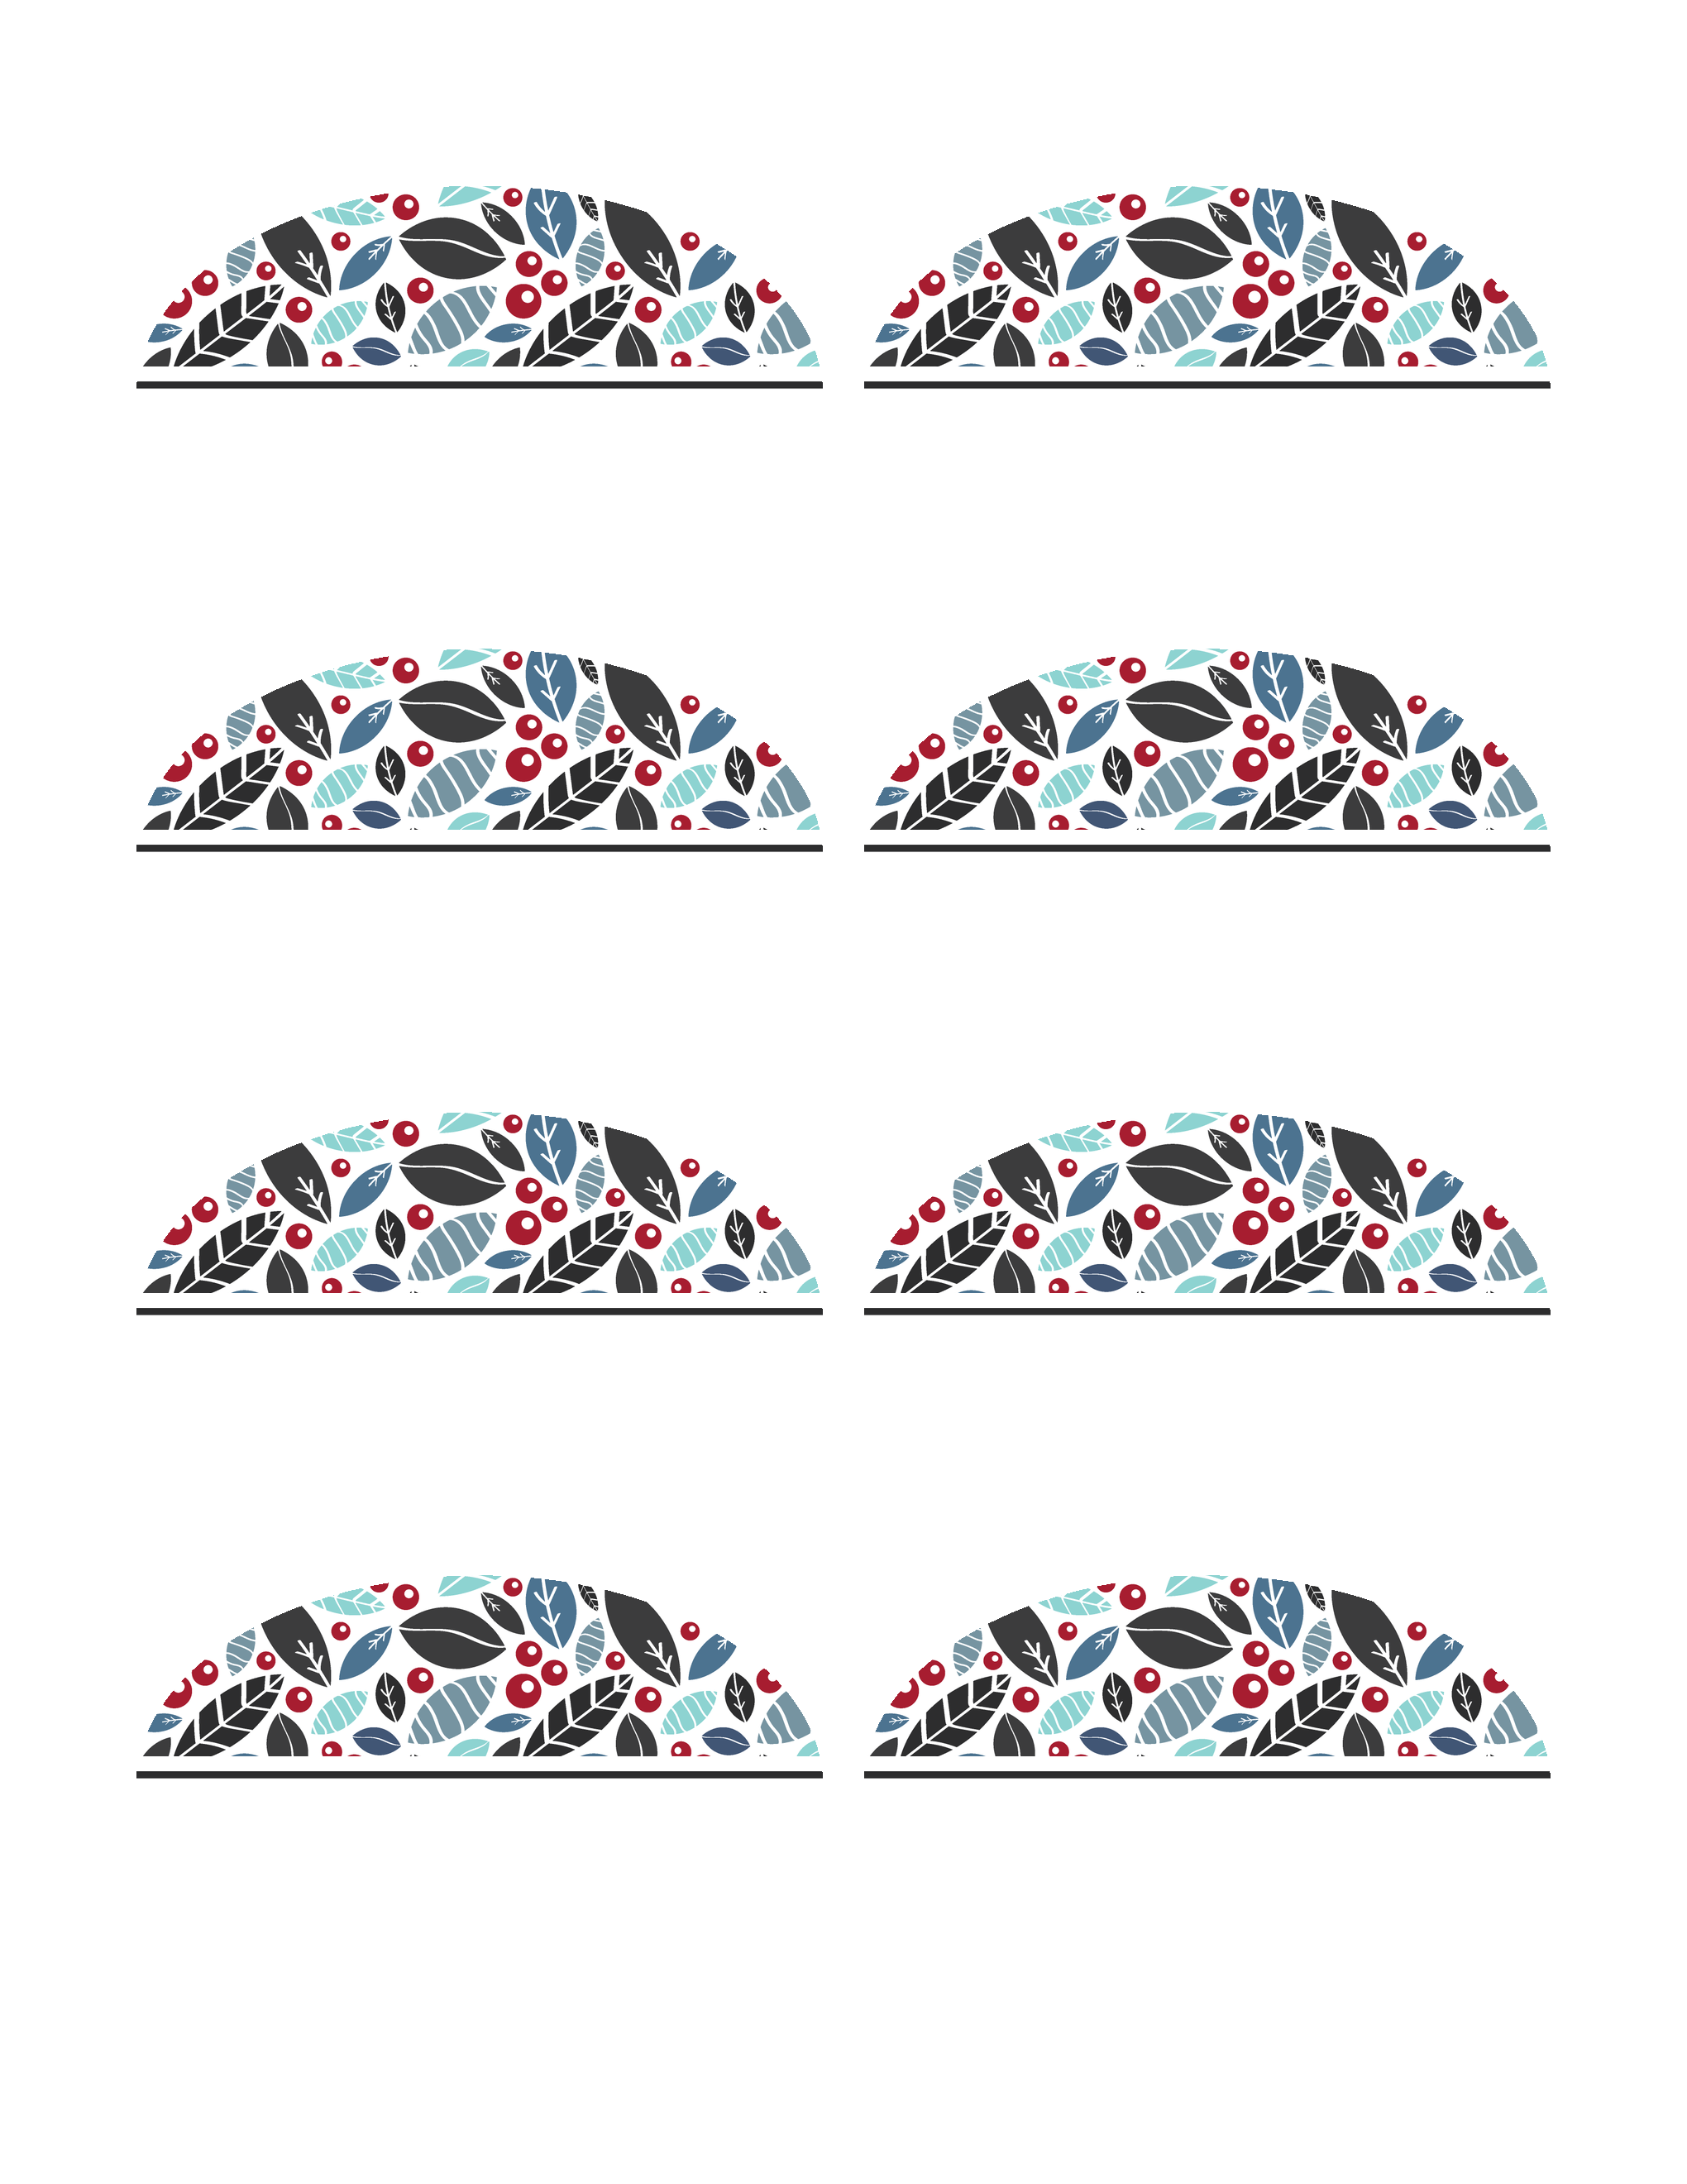
Fill in your text here
Fill in your text here
Fill in your text here
Fill in your text here
Fill in your text here
Fill in your text here
Fill in your text here
Fill in your text here

